Linear Programming Calculator - Simplex

User Manual

Contents

1. Prequisites: 3

2. First look at Linear Programming Calculator 3

3. Home GUI description: 4

4. Procedure of operation: 6

5. About linear programming calculator 11

1. Pre-requisite:

Please make sure that you are running compatible software with Linear Programming Calculator functionality enabled.

1. First look at Linear Programming Calculator

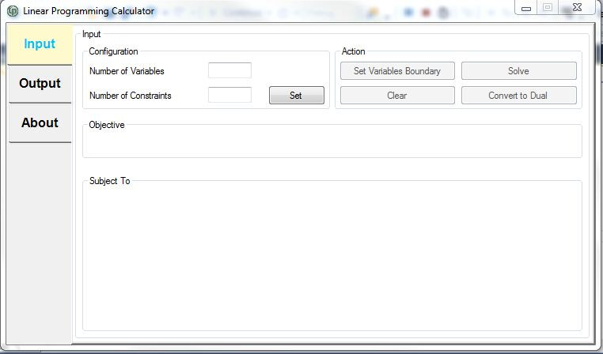

Figure 1: Main GUI of the Most Recent Application.

1. Home GUI description:

3

2

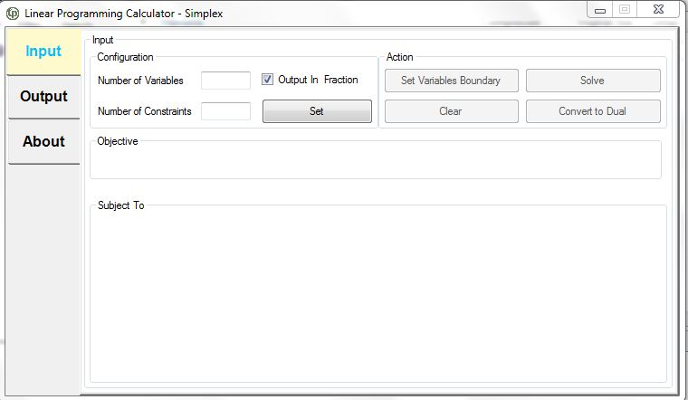

5

4

1

|  |  |
| --- | --- |
| Navigation area | Functional Description |
| 1. Tab layout | Navigate the display option of component. The tab traversal order is generally from top to bottom. Input tab will be selected upon startup. |
| 1. Input configuration | User set the number of variables and the constraints. |
| 1. Action button | Contain four buttons that are set variable boundary, solve, clear, and convert to dual buttons. |
| 1. Objective of the equation | Maximize or minimize can be selected. The equation will be generated but the value need to fill up by user. |
| 1. Constraint of the standard LP | Constrain equation will be generated but the value need to fill up by user. |

Action Toolbar button:

|  |  |
| --- | --- |
| Buttons | Function Description |
| C:\Users\USER\Desktop\set n.JPG | Set to generate the number of variable, constraint and objective equation which depend on the input. |
| C:\Users\USER\Desktop\abt.JPG | Set the fraction display format at the output display table. |
| C:\Users\USER\Desktop\setb.JPG | Set the Boundary of the variable depends on the mathematic requirement. |
| C:\Users\USER\Desktop\convert.JPG | Convert the equation to dual function |
| C:\Users\USER\Desktop\sole.JPG | Solve the equation base on the variable and constraint. |
| C:\Users\USER\Desktop\cla.JPG | Clear all the input variable that user had enter in the box. |

1. Procedure of operation:

4.1.1 Navigate to the input configuration of the main menu. Fill in the number of variable and constraint. Only numbers are allowed to be inserted into the box.

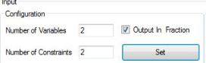

Figure 4.1 Input of the linear programming calculator.

C:\Users\USER\Desktop\abt.JPG4.1.2 The output display value is in fraction by default. To display as decimal, uncheck the

4.1.3 Click C:\Users\USER\Desktop\se.JPG button to set the boundary of the variables and constrains.

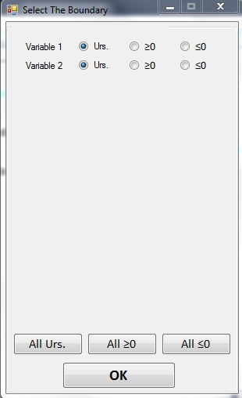

Figure 4.2 Boundary constrain window of the variables.

4.1.4 A window will pop out and user need to select the boundary condition for each variables. To select all unsigned variable, click onC:\Users\USER\Desktop\abt.JPG. If all the variables are positive, click on C:\Users\USER\Desktop\abt.JPG button. If all variable is negative, click on C:\Users\USER\Desktop\gui.JPG button.

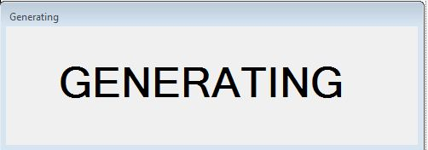

Figure 4.3 Generating Splash form.

4.1.5 A splash form of generating will pop out to indicate the variable and constraint of equation is generating.

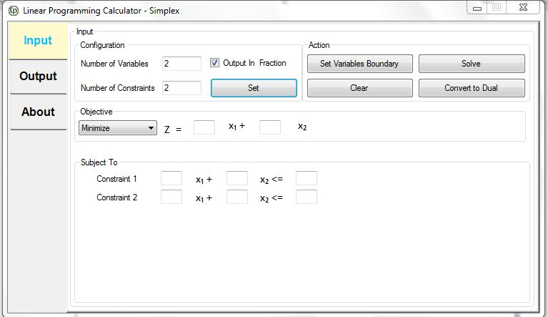

Figure 4.4 Objective equation and the constrain number being generated.

4.1.6 The equation can be select either maximize or minimize by click the C:\Users\USER\Desktop\mas.JPG show a drop list of selection. Fill up the equation variable

C:\Users\USER\Desktop\eq.JPG

4.1.7 Fill up the constrain variable at the subject to constrain section.

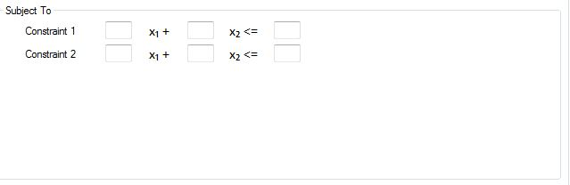

Figure 4.5 Subject to constrain section.

C:\Users\USER\Desktop\sole.JPG4.1.8 Click solve button to solve the linear optimization. The GUI will switch to output form.

Highlight Options

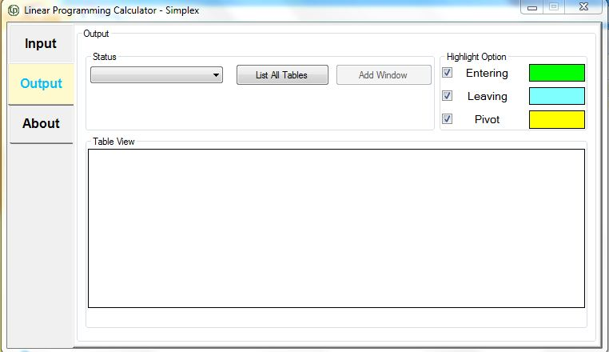

Output Configurations

Display different tables

Figure 4.6 Output display of GUI.

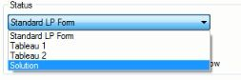

Figure 4.7 Example of selection in the combo box.

4.1.9 The solution table of each iteration of the Linear Programming can be changed through the combo box at the output configuration. Left-click the combo box and select the desire table.

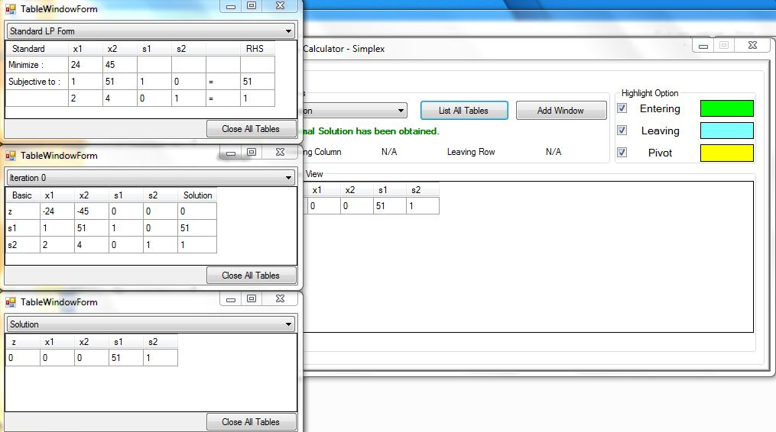

C:\Users\USER\Desktop\list.JPGFigure 4.8 multiple tables of window

4.1.10 Multiple tables of window can be view by clicking List All Table button.

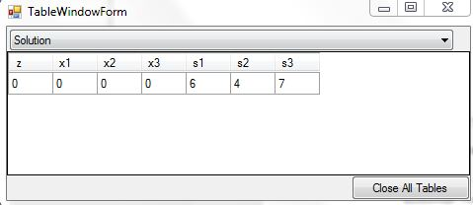

Figure 4.9 TableWindowForm

4.1.11 Click the drop list on top of table to display different other tables. Click Close All Table to close all display table windows.

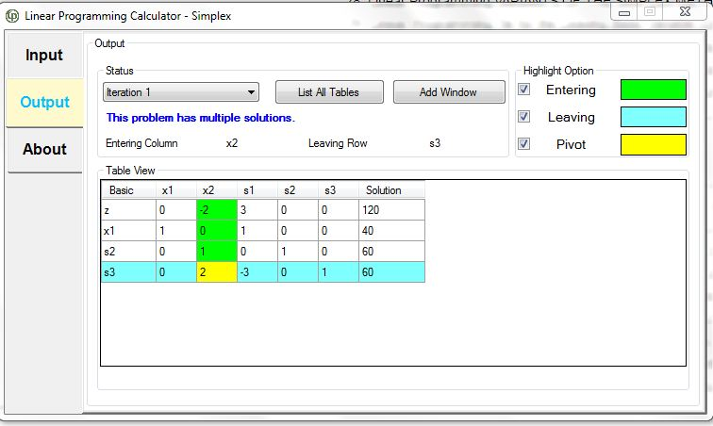

Figure 4.10 Display of table in TableView

4.1.12 Figure 4.10 shows the Entering variable, leaving variable and pivot will be highlighted in different colors. Both entering and leaving variable will be highlighted in green color and sky blue while pivot value highlighted in yellow color.

1. About linear programming calculator

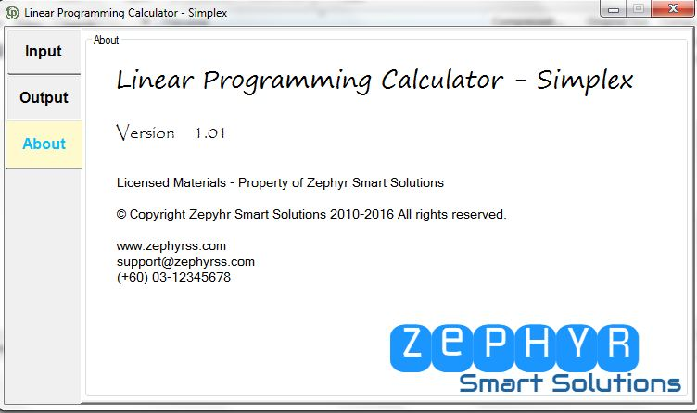

Figure 5.1 About linear programming